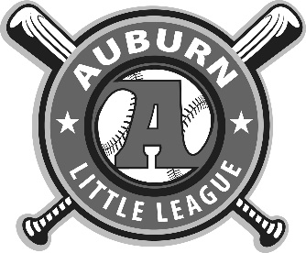

**Auburn NY Little League Manager Code of Conduct**

Youth sports programs play an important role in promoting the physical, social, and emotional development of children.  As managers and coaches in Auburn NY Little League you should be models of good sportsmanship and behavior for your child and all children in the community including participants and spectators alike.

The Auburn NY Little League Board of Directors ask that you pledge to be responsible for your words and actions while coaching, officiating, and participating in league events, and that you conform your behavior to the following Code of Conduct:

* Place the emotional and physical well-being of players ahead of personal desire to win.
* Treat each player as an individual, remembering the large range of emotional and physical development for the same age group.
* Do your best to provide a safe playing environment for all players.
* Do your best to organize practices that are fun and challenging for all players.
* Lead by example in demonstrating fair play and sportsmanship to all players.
* Teach the rules of the game to all players, officials, and parents.
* Remember that you are a youth sports coach and that the game is for children and not adults.
* Do not abuse other coaches, umpires, parents, or players.
* Promote fun, fairness, and sportsmanship over winning.
* Do not engage in the use of profanity or other offensive language.
* Encourage all team members to treat all players, teammates, coaches, officials, and parents with respect.
* Emphasize and foster a team atmosphere and not individual achievements.
* Be responsible for league policies.
* Return all equipment and player evaluations per league policies.

I also agree that if I fail to abide by the aforementioned rules and guidelines, I will be subjected to disciplinary action levied by the Auburn NY Little League Board of Directors or Code of Conduct Committee that could include, but is not limited to the following:

* Verbal warning
* Written warning
* Manager/coaches suspension for game(s) and/or season
* Manager/coach removal from all league activities

The Auburn NY Little League Board of Directors retains the sole authority to determine what, if any, disciplinary action is appropriate for any conduct infraction.

Name: ____________________________

Signed: ___________________________ Date: ___________